IT2654 Systems Administration & Security

Tutorial 8

Discuss within your groups and prepare the answers to be presented in class.

- What is the difference between Linux and a Operating System (if any)? Why has Linux overtaken Unix?
Linux is a kernel engine (core), OS is a kernel + shell

Unix proprietary (license)
Linux open source

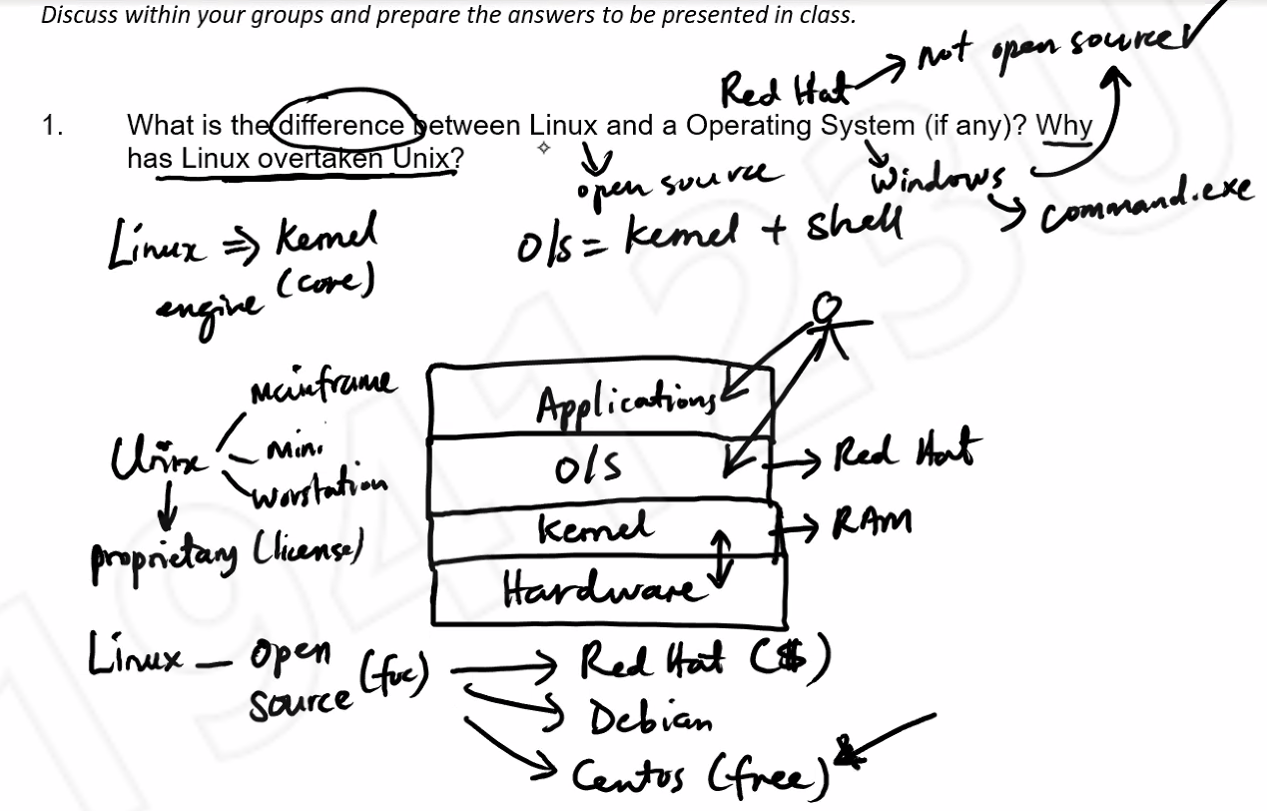

- Explain the following Linux commands:
- su
Creates a new shell as the root user (in user environment)
- su –
Creates a new shell as the root user (in root environment)
Still better to use
- sudo
Runs commands as the root user
User account must be in the /etc/sudoers file

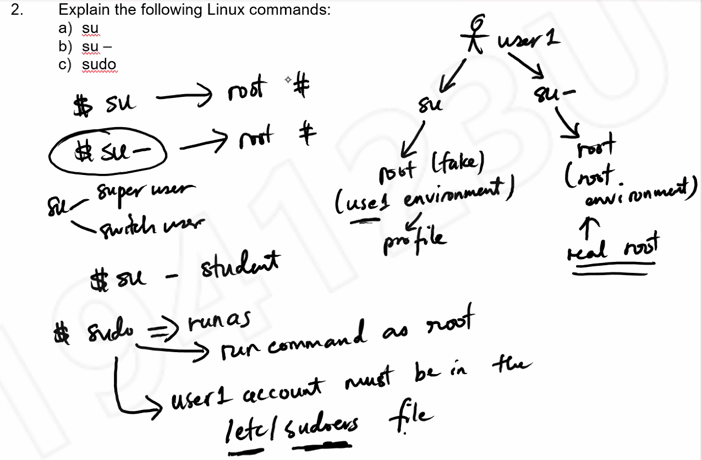

- Based on the figure below, what would happen if you type the following commands in the CLI (terminal) in sequence? Which is absolute path and which is relative path?
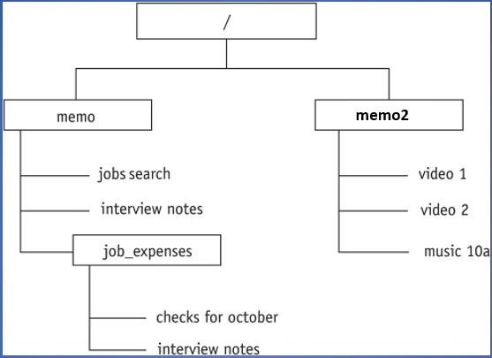
- cd /
Absolute path, root directory
- cd memo/job_expenses
Relative path (based on his starting point)
- cd ..
Goes to parent directory, relative path
- cd ../memo2
Relative path
- cd /memo/job_expenses
Absolute path
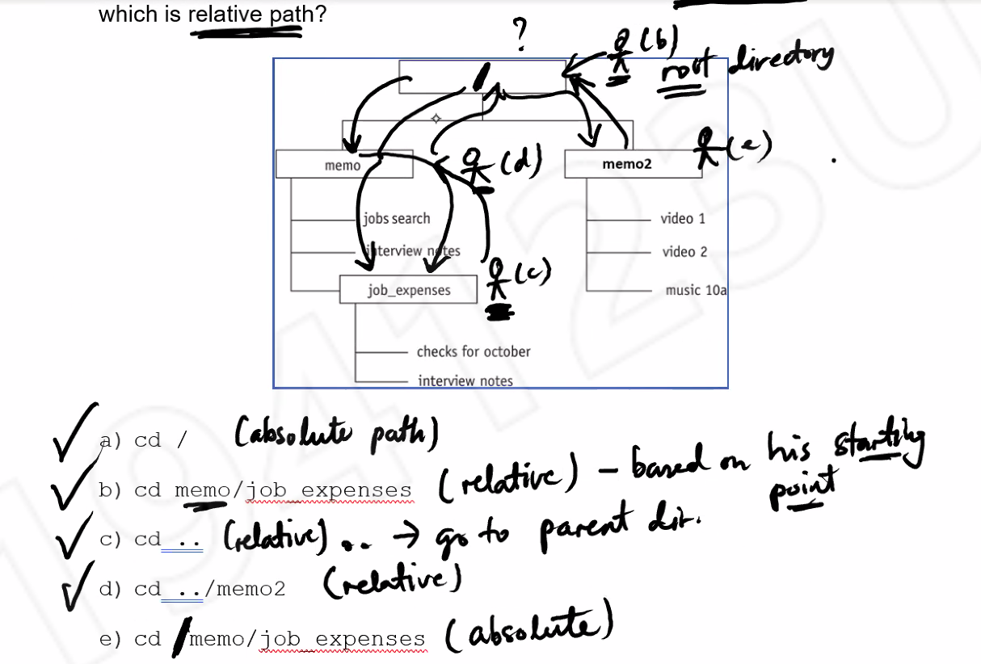

cd goes to user’s home directory
- How does Linux differ from Windows in disk management? (for example in adding a new hard disk to the system)

Linux Folders and files, first file is called /dev/sda. First partition is /dev/sda1. Second partition is /dev/sda2. Default mount is at /media

Windows has drive letters, not compulsory to mount

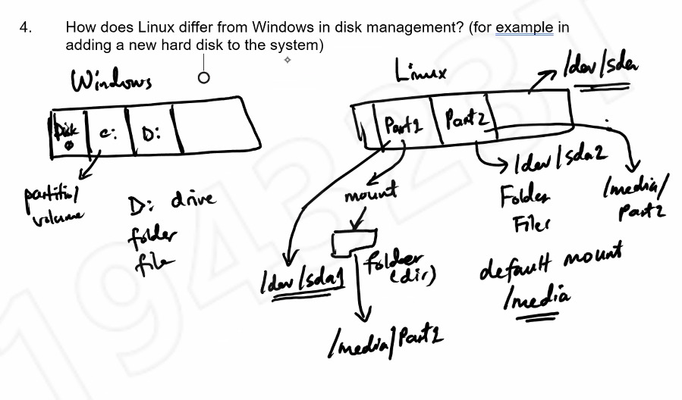

- Find the Linux equivalent commands for the following Windows DOS commands:

DOS Command | Linux Command | Remarks
Cd | cd | Change directory
Type <filename> | cat | List contents of a file
Dir | ls | List a directory
Md | mkdir | Create a directory
Cls | clear | Clear screen

What is one main difference between Windows DOS command and Linux command?
Linux commands are case sensitive, DOS commands are case insensitive

- List the various ways to get help on Linux command in the CLI (terminal) mode.
$password –help list of options
$man password man page many sections (DEFAULT)
$whatis password one line man page, shows sections available. E.g. password(1), password(5)

